**(AIAC)Lab Assignment 3. 6**

N.Srishanth

2303A51907

Batch-12

**Task-1:**

**Tasks to be completed**

1. **Baseline Prompt Testing**

Choose 5 typical user queries, for example:

“Explain, What, Define, Why, What” • Run these prompts in a chat-based AI model and record the raw responses.

1. **Prompt Refinement**

Rewrite each query using the following strategies:

* + Add 5 different contexts (school level, competitive exam, real-life application, mathematical focus, conceptual focus).
  + Make the task explicit (e.g., “List and explain Newton’s three laws with one real-world example each.”).
  + Break the query into subtasks (definition → explanation → example). Run these prompts in a chat-based AI model and record the raw responses. **Prompt:**

1. Explain Newton’s laws of motion. 2.What is force? 3.Define inertia. 4.Why does an object stop moving?

5. What is acceleration?

**Code:**

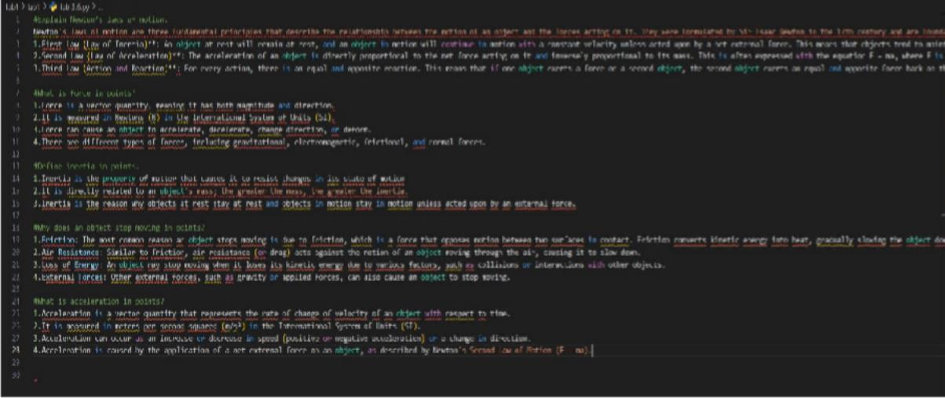

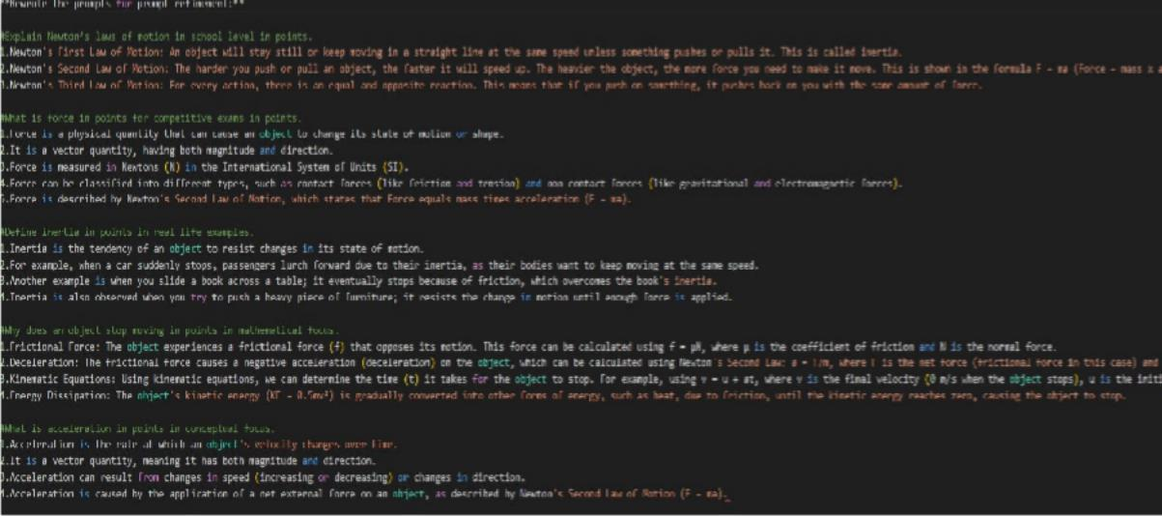

Output:

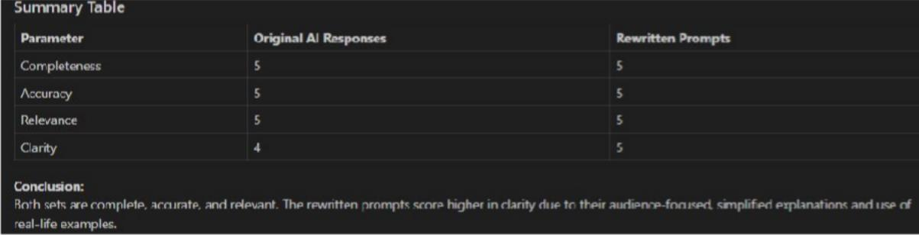

Explanation:

These prompts guide you to explore key concepts in physics related to motion. They ask you to explain Newton’s laws, which describe how forces affect movement, and to define force itself as a push or pull that changes an object’s state. You’re also asked to define inertia, the tendency of objects to resist changes in their motion. The prompts encourage you to think about why objects stop moving, often due to forces like friction.

**Task 2:**

**Tasks to be completed**

1. **Baseline Prompt Testing**

Choose 5 common user queries, such as:

* + “What, Explain, How, What, Difference”

Run these prompts in a chat-based AI model and record the raw responses.

1. **Prompt Refinement** Rewrite each query by:
   * Adding 5 contexts (beginner, exam-oriented, real-world analogy, syntax-focused, performance-focused).
   * Making instructions explicit (e.g., “Define a Python loop and show one example for for-loop and while-loop.”).
   * Breaking into subtasks (definition → syntax → example → use case).

**Prompt:**

1.What is a loop in Python? 2.Explain lists in Python. 3.How does a function work?

1. What is the difference between list and tuple?
2. What is Python?

**Code:**

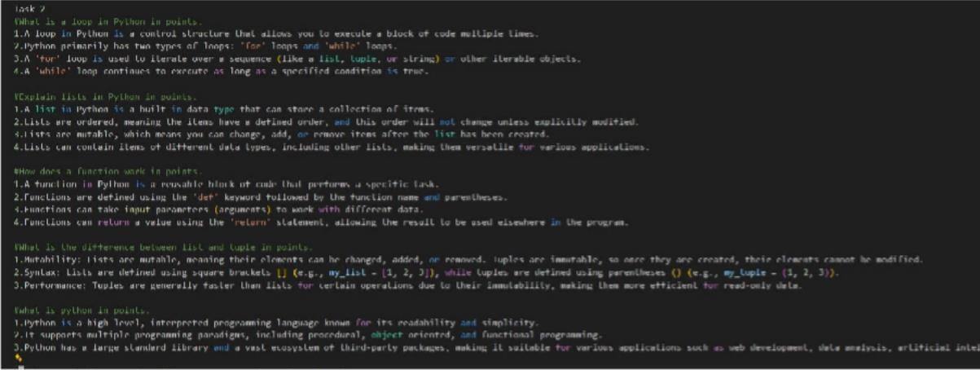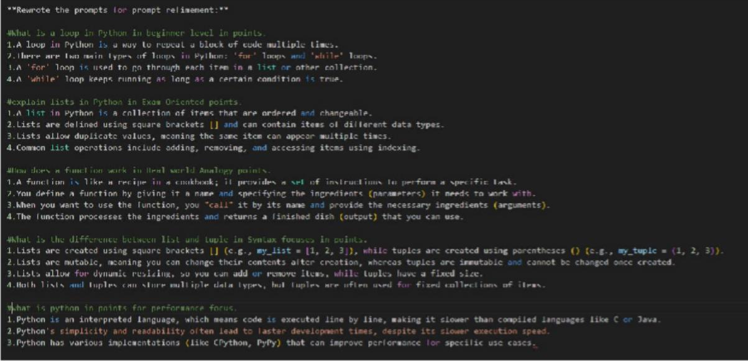

**Output:**

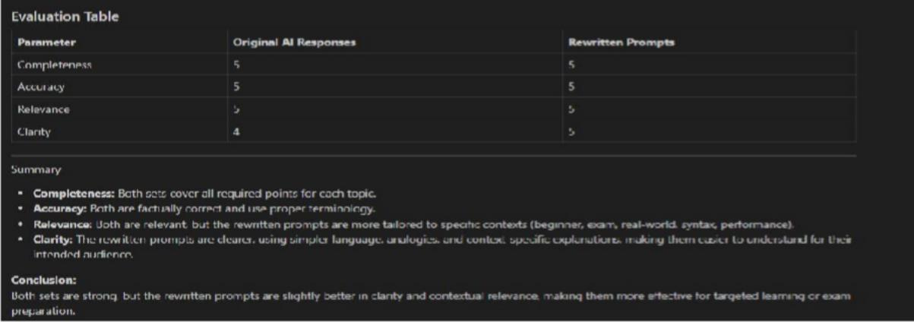

**Explanation:**

These prompts are designed to help you understand basic Python programming concepts. They ask you to explain what a loop is, which is a way to repeat actions in code. You’re also asked to describe lists, which are collections of items that can be changed. The prompts include explaining how functions work, meaning reusable blocks of code that perform specific tasks. You’re encouraged to compare lists and tuples, noting that lists are mutable while tuples are immutable. Finally, you’re asked to define Python itself, which is a popular, high-level programming language known for its simplicity and versatility.

**Task 3:**

**Tasks to be completed**

1. **Baseline Prompt Testing**

Select 5 typical queries, for example:

* + “What, Explain, What, Define, What”

Run these prompts in a chat-based AI model and record the raw responses.

1. **Prompt Refinement** Refine each query by:
   * Adding 5 contexts (academic, industry, beginner-friendly, mathematical, interview-focused).
   * Making tasks explicit (e.g., “Define supervised learning and explain it with one real-world example.”). • Breaking into subtasks (definition → types → example → limitation).

**Prompt:**

1.What is machine learning? 2. Explain supervised learning. 3.Define overfitting. 4.What is regression? 5.What is classification?

**Code:**

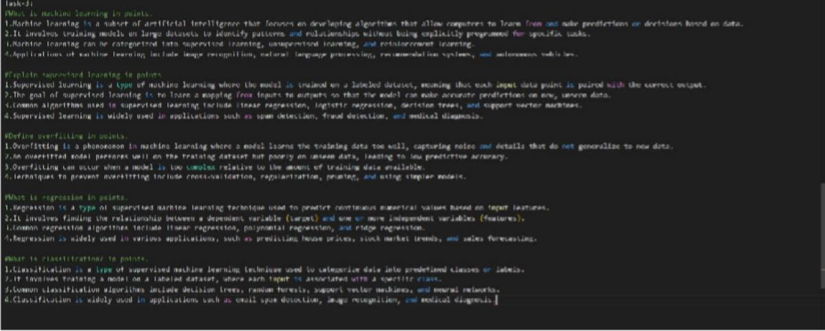

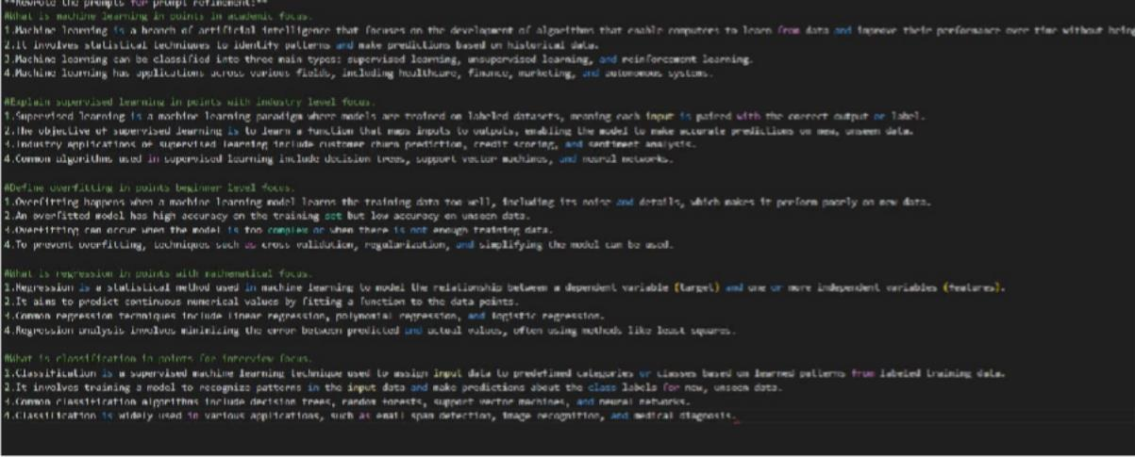

**Output:**

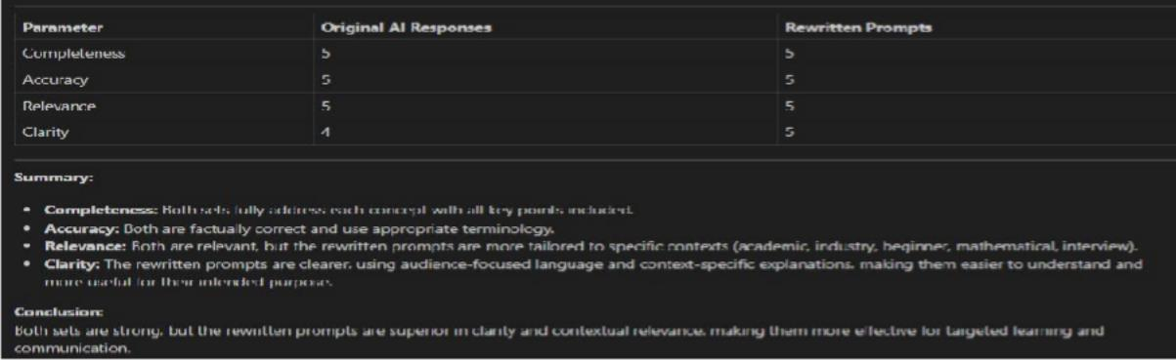

**Explanation:** These prompts focus on fundamental concepts in machine learning. They ask you to define machine learning, which is a field where computers learn from data to make predictions or decisions. You’re prompted to explain supervised learning, a method where models are trained on labeled data. The prompts include defining overfitting, which happens when a model learns the training data too well and performs poorly on new data. You’re also asked to explain regression, a technique for predicting continuous values, and classification, which involves sorting data into categories. Each prompt helps you understand key ideas used in building and evaluating machine learning models.

**Task 4:**

**Tasks to be completed**

1. **Baseline Prompt Testing**

Choose 5 common queries, such as:

* + “Explain, What, Difference, where, how”

Run these prompts in a chat-based AI model and record the raw responses.

1. **Prompt Refinement**

Rewrite each prompt by:

* + Adding 5 contexts (theory exam, practical lab, interview prep, real-world database, optimization focus).
  + Making instructions explicit (e.g., “Explain SQL JOIN types with syntax and examples.”). • Breaking into subtasks (definition → syntax → example → use case).

**Prompt:**

1.What is SQL? 2.Explain joins. 3.Difference between WHERE and HAVING. 4.How does indexing work?

5.What is normalization?

**Code:**

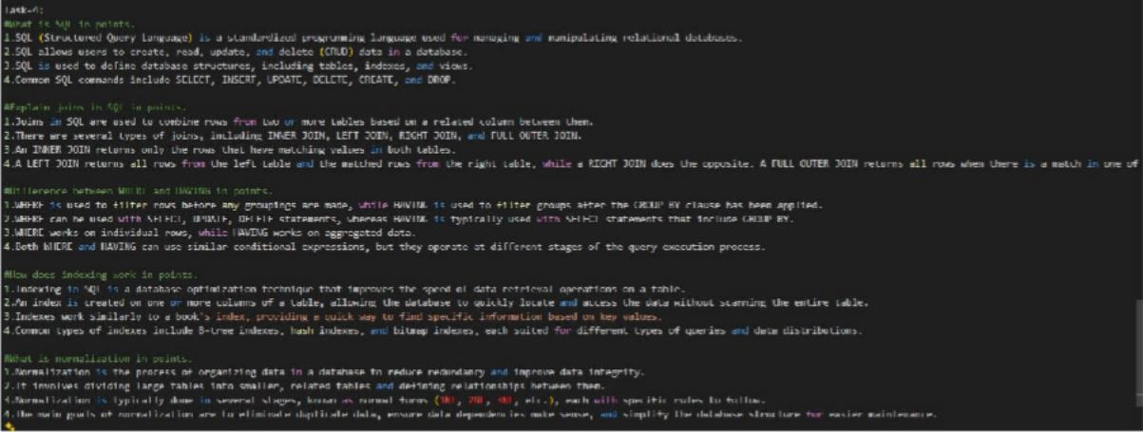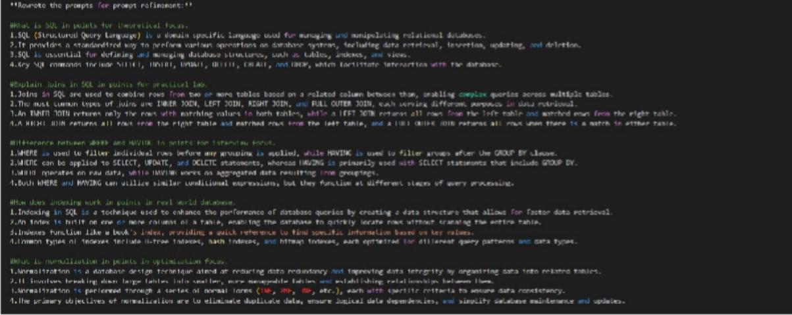

**Output:**

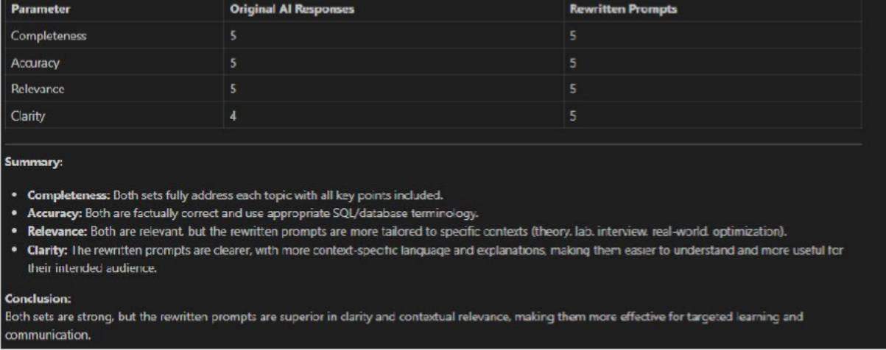

**Explanation:** These prompts are about key concepts in SQL and database management. They ask you to define SQL, which is a language used to manage and query databases. You’re prompted to explain joins, which combine data from multiple tables based on related columns. The prompts include distinguishing between WHERE and HAVING clauses, where WHERE filters rows before grouping and HAVING filters groups after aggregation.

**Task 5:**

**Tasks to be completed**

1. **Baseline Prompt Testing**

Select 5 user queries, for example:

* + “Explain, What, Difference, where, how”

Run these prompts in a chat-based AI model and record the raw responses.

1. **Prompt Refinement** Rewrite each query by:
   * Adding 5 contexts (school exams, competitive exams, real-life analogy, formula-based, step- by-step solving).
   * Making tasks explicit (e.g., “Define probability and solve one simple numerical example.”). • Breaking into subtasks (definition → formula → example → common mistakes). **Prompt:**

**Code:**

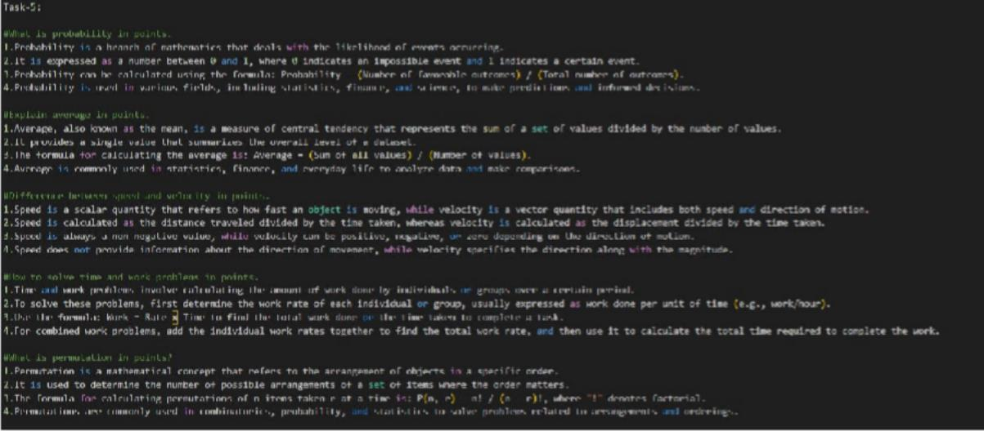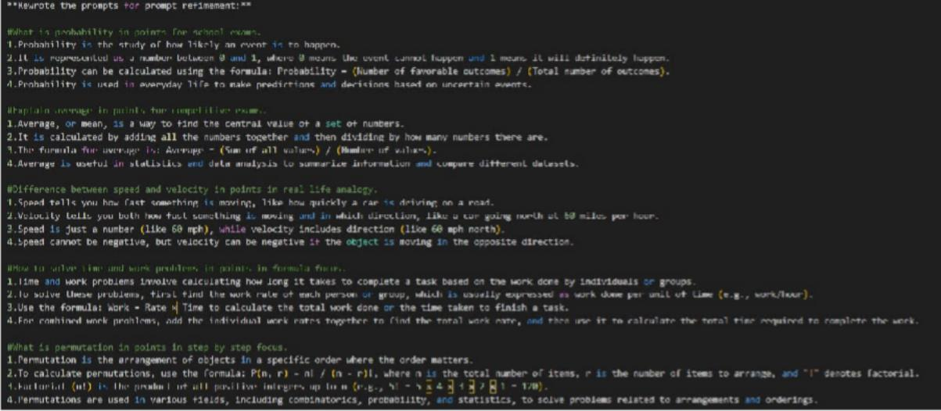

**Output:**

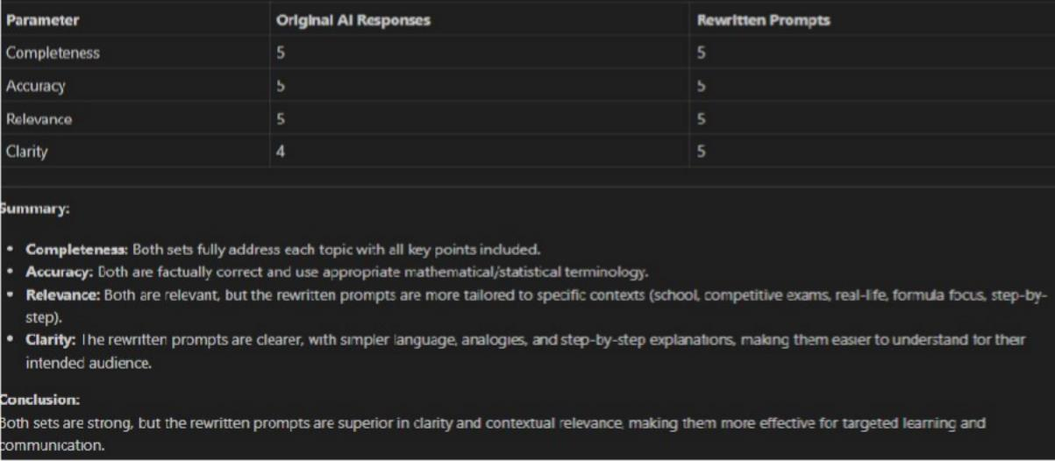

**Explanation:**

These prompts are designed to test and reinforce understanding of fundamental concepts in mathematics and physics. Each prompt targets a specific topic, such as probability, averages, speed versus velocity, time and work problems, and permutations. They encourage clear, structured, and focused responses, often used in exams or interviews. The prompts help learners practice explaining concepts concisely and accurately. Overall, they serve as effective tools for both teaching and self-assessment.